**• Explain git ignore**

**Ans. .gitignore** is a plain text file that tells Git which files or folders to ignore when you run *git add* or *commit* changes. Ignored files will not be tracked in your repository.

**• Explain how to ignore unwanted files using git ignore**

**Ans.** Each line in **.gitignore** is a pattern telling Git what to skip. For Example, in Notepad:

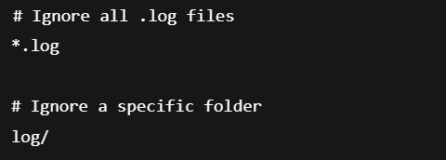

Now commit the **.gitignore** changes.